Extracto Norma - https://www.chinesestandard.net/PDF.aspx/GB1499.2-2024
GB NATIONAL STANDARD OF THE PEOPLE’S REPUBLIC OF CHINA ICS 77.140.15 CCS H 44 Replacing GB/T 1499.2-2018 Steel for the reinforcement of concrete - Part 2.Hot rolled ribbed bars Issued on: JUNE 25, 2024 Implemented on: SEPTEMBER 25, 2024 Issued by. State Administration for Market Regulation; Standardization Administration of the People's Republic of China.
Table of Contents
Foreword... 3 Introduction... 5 1 Scope... 6 2 Normative references... 6 3 Terms and definitions... 8 4 Classification, designation... 9 5 Size, shape, weight, and allowable deviation... 10 6 Smelting and performance... 14 7 Test methods... 18 8 Inspection rules... 21 9 Packaging, marks, and quality certification... 22 Annex A (informative) Formula for calculating the relative rib area of steel bars... 24 Annex B (normative) Macroscopic metallography, section Vickers hardness, microstructure and inspection methods of steel bars... 25 Annex C (normative) Rules for characteristic value inspection... 28
Foreword
This document was drafted in accordance with the rules given in GB/T 1.1-2020 "Directives for standardization - Part 1.Rules for the structure and drafting of standardizing documents". This document is Part 2 of GB 1499 "Steel for the reinforcement of concrete". The following parts of GB 1499 have been released. - Part 1.Hot rolled plain bars; - Part 2.Hot rolled ribbed bars; - Part 3.Welded fabric. This document replaces GB/T 1499.2-2018 "Steel for the reinforcement of concrete -- Part 2.Hot rolled ribbed bars". Compared with GB/T 1499.2-2018, in addition to structural adjustments and editing changes, the main technical changes are as follows. - Change the allowable weight deviation (see Table 4 of this Edition; Table 4 of Edition 2018); - Change the requirements for fatigue performance (see 6.5 of this Edition; 7.6 of Edition 2018); - Add the sampling requirements for size and surface quality testing (see Table 8 of this Edition); - Change the accuracy of measuring total weight for weight deviation (see 7.4.1 of this Edition; 8.4.1 of Edition 2018); - Change the requirements for mixed batches (see 8.3.2 of this Edition; 9.3.2 of Edition 2018); - Change the inspection items and sampling quantity (see 8.3.3 of this Edition; 9.3.2 of Edition 2018); - Revise the re inspection regulations for weight deviation items (see 8.3.5 of this Edition; 9.3.5 of Edition 2018); - Change the regulations on packaging, marks, and quality certification (see Chapter 9 of this Edition; Chapter 10 of Edition 2018). Attention is drawn to the possibility that some of the elements of this document may be the subject of patent rights. The issuing authority shall not be held responsible for identifying any or all such patent rights. This document was proposed by and shall be under the jurisdiction of the Ministry of Industry and Information Technology of the People's Republic of China. Versions of standard substituted by this document are. - It was released in 1979 as GB 1499-1979.The first revision was made in 1984.The second revision was in 1991.The third revision was in 1998; - The fourth revision in 2007 was GB 1499.2-2007; - The fifth revision in 2018 was GB/T 1499.2-2018; - This is the sixth revision.
1 Scope
This document specifies the classification, designation, size, shape, weight and allowable deviation, smelting and performance, test methods, inspection rules, packaging, marks and quality certificates for the hot rolled ribbed bars the reinforcement of concrete (hereinafter referred to as steel bars). This document is applicable to hot rolled bars and hot rolled bars of fine grains for the reinforcement of concrete. This document is not applicable to recycled steel bars and waste heat treated steel bars that are re rolled from finished steel products.
2 Normative references
The following referenced documents are indispensable for the application of this document. For dated references, only the edition cited applies. For undated references, the latest edition of the referenced document (including any amendments) applies. GB/T 222, Permissible tolerances for chemical composition of steel products GB/T 223.5, Steel and iron -- Determination of acid-soluble silicon and total silicon content -- Reduced molybdosilicate spectrophotometric method GB/T 223.11, Iron, steel and alloy -- Determination of chromium content -- Visual titration or potentiometric titration method GB/T 223.12, Methods for chemical analysis of iron, steel and alloy. The sodium carbonate separation-diphenyl carbazide photometric method for the determination of chromium content GB/T 223.14, Methods for chemical analysis of iron, steel and alloy. The N-benzoyl- N-phenylhydroxylamine extraction photometric method for the determination of vanadium content GB/T 223.17, Methods for chemical analysis of iron, steel and alloy -- The diantipyrylmethane photometric method for the determination of titanium content GB/T 223.19, Methods for chemical analysis of iron, steel and alloy. The neocuproine-chloroform extraction photometric method for the determination of copper content GB/T 223.23, Iron, steel and alloy -- Determination of nickel content -- The dimethylglyoxime spectrophotometric method GB/T 223.26, Iron, steel and alloy -- Determination of molybdenum content -- The thiocyanate spectrophotometric method
3 Terms and definitions
For the purposes of this document, the following terms and definitions apply.
4 Classification, designation
4.1 Steel bars are classified into 400, 500, and 600 grades based on their yield strength characteristic values. 4.2 The composition and meaning of steel bar designations are shown in Table 1. Table 1 -- Composition and meaning of steel bar designations
5 Size, shape, weight, and allowable deviation
5.1 Nominal diameter range The nominal diameter range of steel bars is 6 mm~50 mm. 5.2 Nominal cross-sectional area and theoretical unit weight The nominal cross-sectional area and theoretical unit weight of steel bars shall comply with the provisions of Table 2. Table 2 -- Nominal cross-sectional area and theoretical unit weight of steel bars 5.3 Allowable deviations in shapes and dimensions 5.4 Delivery type and allowable deviation 5.4.1 Steel bars shall be delivered in fixed length according to straight bars. The delivery length shall be specified. The allowable deviation for length is. 5.4.2 Steel bars with a diameter not exceeding 16 mm are allowed to be delivered in coils. Cut the head and tail when delivering. Each coil shall consist of one steel bar. Each batch is allowed to have 5% of the number of coils (two coils are allowed if there are less than two coils) composed of two steel bars. The weight of the inventory shall be determined through negotiation between the supplier and the purchaser. 5.5 Bending degree and end 5.6 Weight and allowable deviation 5.6.1 Steel bars shall be delivered by weight. There are two delivery methods. in actual weight and theoretical weight. The theoretical weight of steel bars is calculated by multiplying the length of the steel bars by the theoretical weight per meter of steel bars in Table 2. 5.6.2 The allowable deviation between the actual weight and theoretical weight of steel bars shall comply with the provisions of Table 4.
6 Smelting and performance
6.1 Smelting method Steel shall be smelted using a converter or electric arc furnace. HRB500E, HRBF500E, Nominal diameter d/mm Deviation between actual weight and theoretical weight η/% and HRB600 shall undergo external refining. 6.2 Chemical composition 6.3 Mechanical properties 6.3.1 The mechanical property characteristic values of steel bars, such as lower yield strength ReL, tensile strength Rm, elongation at break A, and maximum total elongation at break Agt, shall comply with the provisions of Table 6.For the mechanical performance characteristic values listed in Table 6, R°eL/ReL is the maximum guaranteed value and others are the minimum guaranteed values. 6.3.2 The elongation at break A of various designations of steel bars with nominal diameters ranging from 28 mm~40 mm is allowed to be reduced by 1%. The elongation at break A of each designation of steel bars with a nominal diameter greater than 40 mm is allowed to be reduced by 2%. 6.4 Process performance 6.5 Fatigue performance When applied to concrete structures or components that bear dynamic cyclic effects such as highway bridges and culverts, railway bridges and culverts, and underground structures of urban rail transit, corresponding fatigue performance test reports of corresponding designations and specifications shall be provided. Fatigue performance testing shall be conducted in accordance with GB/T 28900, with 5 steel bars cut from different pieces (coils). 6.6 Connection performance 6.6.1 The welding and mechanical connection process of steel bars, as well as the quality inspection and acceptance of joints, shall comply with the provisions of JGJ 18 and JGJ 107. 6.6.2 The welding process for HRBF500 and HRBF500E steel bars shall be determined through testing. 6.6.3 HRB600 steel bars are mechanically connected. Welding is allowed for connection. 6.7 Grain size 6.8 Microstructure The metallographic structure of steel bars shall mainly consist of ferrite and pearlite. There shall be no tempered martensite structure on the core. The macroscopic metallography, cross-sectional Vickers hardness, and microstructure of steel bars shall comply with the provisions of Annex B. After consultation between the supplier and the purchaser, it is allowed not to conduct metallographic examination. 6.9 Surface quality
7 Test methods
7.1 Inspection items 7.2 Tensile, bending, and reverse bending tests 7.2.1 Tensile, bending, and reverse bending test specimens shall not be machined. 7.2.2 The cross-sectional area used to calculate the strength of steel bars is the nominal cross-sectional area listed in Table 2. 7.2.3 Reverse bending test. First bend the specimen in the forward direction by 90°, and keep it at a temperature of 100℃± 10℃ for no less than 30 min after the forward bending. After natural cooling, bend it in the opposite direction by 20°. Both bending angles shall be measured while maintaining the load. Exit-factory inspection allows direct reverse bending at room temperature. Arbitration inspection shall be carried out by reverse bending after the time limit. 7.3 Size measurement 7.3.1 The measurement of the inner diameter of steel bars shall be accurate to 0.1 mm. 7.3.2 The measurement of the height of longitudinal and transverse ribs of steel bars adopts the method of measuring the average height of the center of the transverse ribs on both sides of the same section. That is, measure the maximum outer diameter of the steel bar, subtract the inner diameter at that location, and obtain half of the value as the rib height at that location, which shall be accurate to 0.1 mm. 7.3.3 The spacing between the transverse ribs of the steel bars is measured using the method of measuring the average rib spacing. That is, measure the center distance between the 1st and 11th transverse ribs on the same side of the steel bar. The value divided by 10 is the spacing between the transverse ribs, which shall be accurate to 0.1 mm. 7.3.4 Measure the chord length between the two ends of adjacent transverse ribs projected perpendicular to the axis plane of the steel bar by measuring the gap between the ends of the transverse ribs of the steel bar. The schematic diagram of measuring the gap at the end of the steel bar transverse rib is shown in Figure 2. Keys. 7.4 Measurement of weight deviation 7.4.1 When measuring the weight deviation of steel bars, specimens shall be taken from different steel bars. The quantity is 5 pieces. The length of each specimen shall not be less than 500 mm. The length shall be measured one by one, with an accuracy of 1 mm. When measuring the total weight of the specimen, it shall be accurate to 1 g. 7.4.2 The deviation (%) between the actual weight and theoretical weight of the steel bar shall be calculated according to formula (2). 7.5 Macroscopic metallography, cross-sectional Vickers hardness, microstructure inspection The inspection of macroscopic metallography, cross-sectional Vickers hardness, and microstructure shall be carried out in accordance with the provisions of Annex B. Microstructure shall be used as the basis for arbitration. 7.6 Numerical rounding and judgment The rounding and judgment of the test results shall comply with the provisions of YB/T 081.
8 Inspection rules
8.1 Inspection classification The inspection of steel bars is divided into characteristic value inspection and delivery inspection. 8.2 Characteristic value inspection 8.2.1 Characteristic value inspection is applicable to the following situations. a) Supplier's inspection of product quality control; b) Inspection required by the purchaser and after mutual agreement between the supplier and the purchaser; c) Third party product certification and arbitration inspection. 8.2.2 The characteristic value inspection shall be conducted in accordance with the provisions of Annex C. 8.3 Delivery inspection 8.3.1 Applicable situation Delivery inspection is applicable to the inspection of steel bar acceptance batches. 8.3.2 Batching rules 8.3.3 Inspection items and sampling quantity When the weight of each batch is not more than 60 t, samples shall be taken and inspected according to the requirements in Table 8.When the weight of each batch is greater than 60 t, for every additional 40 t (or the remainder of less than 40 t), 1 tensile test specimen and 1 bending test specimen shall be added. An additional reverse bending test specimen shall be added for steel bars of designations with "E". 8.3.4 Inspection results The inspection results of each inspection item of steel bars (including steel bars straightened by coiling) shall comply with the relevant provisions of Chapter 5 and Chapter 6. 8.3.5 Re-inspection and judgement The re-inspection and judgment of steel bars shall comply with the provisions of GB/T 17505.The weight deviation of steel bars shall not be resampled for re-inspection.
9 Packaging, marks, and quality certification
9.1 The surface marks of steel bars shall comply with the following regulations. a) Steel bars shall be marked with the grade mark, production enterprise serial number (the first 2 digits of the administrative division code and the last 3 digits of the license specified in GB/T 2260), and nominal diameter in millimeters on their surface. Allow registered factory names or trademarks to replace the first two digits of the administrative division code. b) The steel bar designation mark is represented by Arabic numerals or Arabic numerals plus English letters. HRB400, HRB500, and HRB600 are represented by 4, 5, and 6, respectively. HRBF400 and HRBF500 are respectively represented by C4 and C5.HRB400E and HRB500E are respectively represented as 4E and 5E. HRBF400E and HRBF500E are respectively represented as C4E and C5E. The factory name is represented by the Chinese Pinyin prefix. The nominal diameter in millimeters is represented by Arabic numerals. c) The mark shall be clear and concise. The size of the mark shall be appropriately specified by the supplier according to the diameter of the steel bars. The transverse ribs intersecting with the logo can be removed. 9.2 Barcodes and QR codes containing product information are allowed to be affixed to the packaging, labels, and quality certificates of steel bars. 9.3 In addition to the above regulations, the packaging, marks, and quality certificate of steel bars shall comply with the relevant provisions of GB/T 2101. ......
Source: Above contents are excerpted from the full-copy PDF -- translated/reviewed by: www.ChineseStandard.net / Wayne Zheng et al.
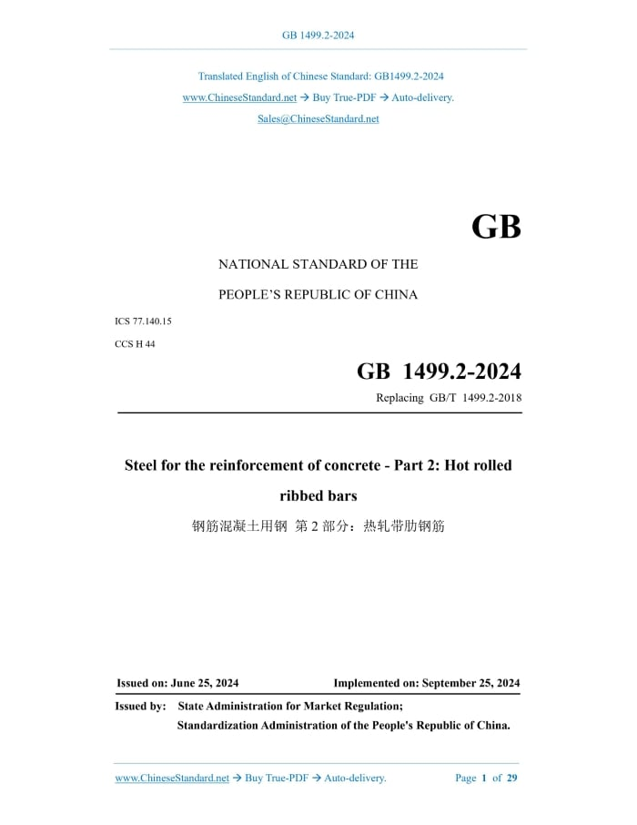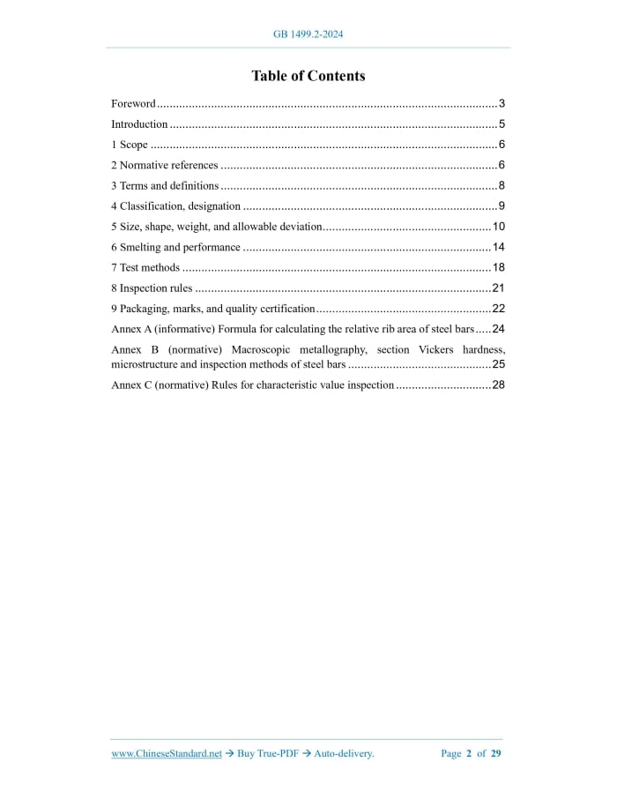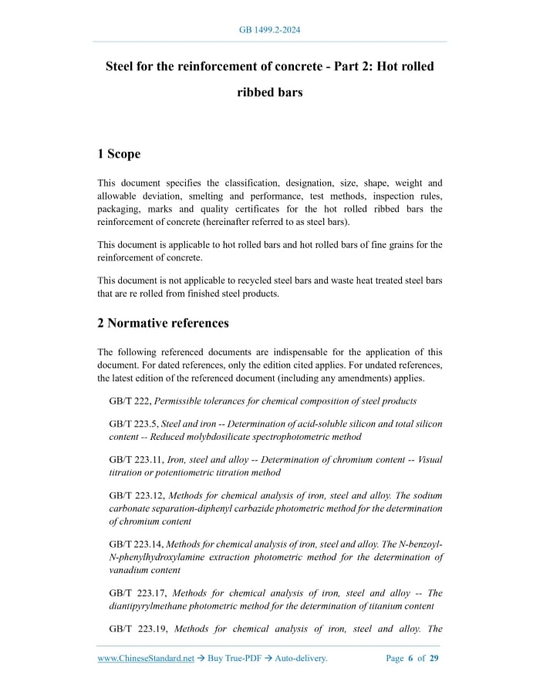

RESUMEN EN ESPANOL (TRADUCIDO UTILIZANDO INTELIGENCIA ARTIFICIAL)
NORMA NACIONAL GB DE LA REPÚBLICA POPULAR CHINA
ICS 77.140.15 | CCS H 44
Sustituye a GB/T 1499.2-2018
Acero para refuerzo de concreto – Parte 2: Barras corrugadas laminadas en caliente
Emitida el: 25 de junio de 2024
Entrada en vigor: 25 de septiembre de 2024
Emitida por: Administración Estatal de Regulación del Mercado; Administración de Normalización de la República Popular China

Índice
Prólogo... 3
Introducción... 5
1 Alcance... 6
2 Referencias normativas... 6
3 Términos y definiciones... 8
4 Clasificación y designación... 9
5 Dimensiones, forma, peso y desviaciones permitidas... 10
6 Fusión y propiedades... 14
7 Métodos de ensayo... 18
8 Reglas de inspección... 21
9 Embalaje, marcado y certificación de calidad... 22
Anexo A... 24
Anexo B... 25
Anexo C... 28

Prólogo
Este documento fue elaborado conforme a GB/T 1.1-2020 “Directrices para la normalización – Parte 1”.
Forma parte de la norma GB 1499 “Acero para refuerzo de concreto”, que incluye:
- Parte 1: Barras lisas laminadas en caliente
- Parte 2: Barras corrugadas laminadas en caliente
- Parte 3: Mallas soldadas
Sustituye a GB/T 1499.2-2018.
Cambios principales:
- Modificación de la desviación de peso permitida
- Cambios en requisitos de fatiga
- Nuevos requisitos de muestreo
- Ajustes en medición de peso
- Cambios en inspección y lotificación
- Revisión de reglas de reinspección
- Actualización de embalaje y marcado

1. Alcance
Este documento establece requisitos para:
- Clasificación
- Designación
- Dimensiones
- Peso
- Propiedades
- Ensayos
- Inspección
- Embalaje y certificación
Aplica a:
- Barras corrugadas laminadas en caliente
- Barras de grano fino para refuerzo de concreto
No aplica a:
- Barras recicladas
- Barras reprocesadas por laminación

2. Referencias normativas
Incluye normas GB/T para:
- Composición química
- Análisis químico (silicio, cromo, vanadio, titanio, cobre, níquel, molibdeno)

3. Términos y definiciones
Se aplican los términos definidos en la norma.

4. Clasificación y designación
- Clasificación por límite elástico:
  - Grado 400
  - Grado 500
  - Grado 600

5. Dimensiones, forma, peso y tolerancias
5.1 Diámetro nominal:
- Entre 6 mm y 50 mm
5.2 Peso teórico:
- Determinado según tabla estándar
5.4 Entrega:
- En barras rectas o rollos (≤16 mm)
5.6 Peso:
- Puede ser:
  - Peso real
  - Peso teórico

6. Fusión y propiedades
6.1 Método de producción:
- Convertidor
- Horno eléctrico de arco
6.3 Propiedades mecánicas:
Incluyen:
- Límite elástico (ReL)
- Resistencia a la tracción (Rm)
- Elongación (A)
6.5 Fatiga:
- Obligatoria para estructuras sometidas a cargas dinámicas
6.6 Conexión:
- Soldadura o conexión mecánica conforme a normas JGJ
6.8 Microestructura:
- Principalmente:
  - Ferrita
  - Perlita
- Prohibido:
  - Martensita templada en el núcleo

7. Métodos de ensayo
Incluyen:
- Ensayos de tracción
- Ensayos de flexión
- Ensayo de doblado inverso
Ejemplo:
- Flexión a 90° + calentamiento + flexión inversa a 20°
Mediciones:
- Precisión de diámetro: 0.1 mm
- Peso: precisión de 1 g

8. Reglas de inspección
Tipos:
- Inspección de valor característico
- Inspección de entrega
Muestreo:
- Hasta 60 toneladas: según tabla
- Más de 60 t: muestras adicionales

9. Embalaje, marcado y certificación
Las barras deben incluir:
- Marca de grado
- Código del fabricante
- Diámetro nominal
Ejemplo de designación:
- HRB400 → “4”
- HRB500 → “5”
- HRB600 → “6”
Se permite:
- Código QR
- Código de barras

